

<Project Name- COMP7780/Project ID-2>

User Story Document
Version 0.1
10/03/2026

Document Tracking
The following chart is used to log of all changes made to this document.
Version | Date of edit/change | Who made the edit/change | Description of edit/change
0.1 | Mar 10, 2022 | Hans Yip | Initial version
0.2 | Mar 10, 2022 | Hans Yip | Added project information
0.3 | Mar 14, 2022 | Hans Yip | Added second cycle info

Introduction
Green World company is a new re-cycling concept organization based in Hong Kong which established on Jan 1, 2026.
Green World’s products were donated by the public and sell to the public with discounted price.
So far, customers need to visit the physical stores to purchase the products.
Green World would like to sell products online and would like to set up an E-shop/website to display their company’s information, product information and be able to sell products online if possible.
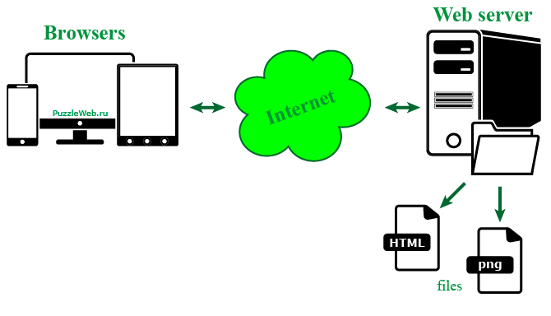

Project Overview

Client would like to set up an E-shop/website to display company’s information and product information. So that products can be sold online if possible.

In addition, client would like to set up PayPal to pay for the orders.

Objective
To reduce customers visiting physical stores, Green World would like to set up an E-shop/website to display their company information, product information and be able to see products online if possible.

Business Case
To set up an E-shop/website so that Green World can display and sell products online.

Risks
Internet access, MySQL database server and PayPal payment server must be up and running.

Out of Scope
Maintenance of MySQL database server and PayPal payment server are out of scope for this project.

User Stories:
User Story ID: 1 (R1)
User Story:
As a web user, I want to access the website so that I can see Green World company and products information.

Acceptance Criteria:
- Ability to access the website.

User Story ID: 2 (R2)
User Story:
As a web user, I want to access the website so that I can see Green World information.

Acceptance Criteria:
- Green World company information will be displayed.

User Story ID: 3 (R3)
User Story:
As a web user, I want to access the website so that product information will be displayed.

Acceptance Criteria:
- Green World product information will be displayed.

User Story ID: 4 (R5)
User Story:
As a web customer, I want to access the website so that I can place my orders.

Acceptance Criteria:
- Customers can place their orders from the website.

User Story ID: 5 (R4)
User Story:
As a web customer, I want to use the PayPal so that I can pay the orders.

Acceptance Criteria:
- PayPal accepts customer’s payment.

User Story ID:
User Story:
As a <type of user>, I want to <feature/function> so that <reason/benefit>.

Acceptance Criteria:
- Ability to gain access to sales systems etc…

User Story ID:
User Story:
As a <type of user>, I want to <feature/function> so that <reason/benefit>.

Acceptance Criteria:
- Ability to gain access to sales systems etc…

Technical Specifications

Input
URL for Green World web site.

Output
Display web pages.

Interface(s)
None.

Assumptions
Web server, MySQL database, and PayPal server are up and running 24/7.

Concerns and Issues

